Sean Buddy, Brandon Burkhart, Michael Jaromnak, Tyler Manogue, Allison Piech

Dr. Xue

SRA 311

11 October 2019

Project Proposal

1. **Project Link**
   1. GitHub Link: <https://github.com/Group7sra/SRA-311-Project>
   2. Manager’s Names: Brandon Burkhart and Allison Piech
2. **Executive Summary**
   1. The organization we are running our risk analysis on is Tower Health.
   2. Tower Health consists of 11,000 team members, 2,000 physicians, and 65 locations. They provide their services to 2.5 million people. The major security challenge Tower Health is protecting health data on ‘smart’ equipment. Smart equipment includes desktop computers, transportable computers that travel to various patients' rooms, blood pressure and heart rate monitoring cuffs, and glucometers.
   3. NIST Model: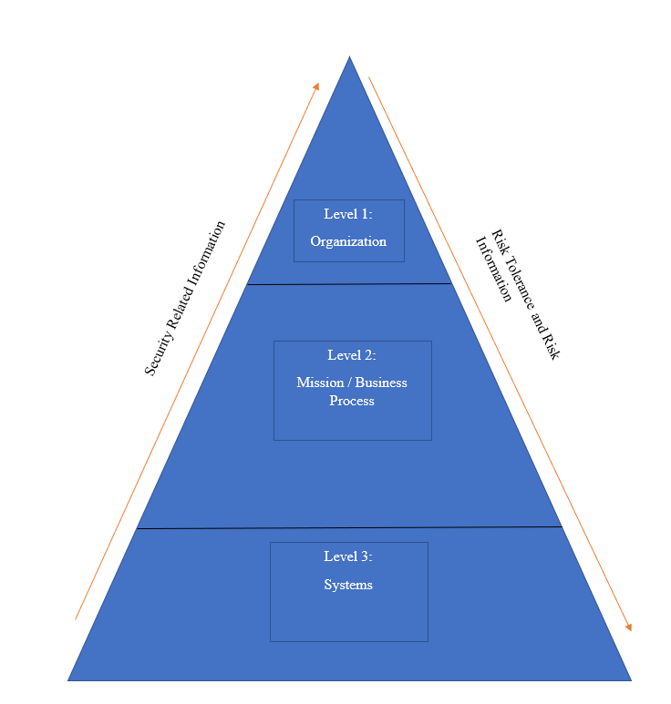
   4. There are many benefits that our project will provide for Tower Health. Using this outline, Tower Health will be able to recognize which parts of its technology sector need updating or alteration. The stakeholders will be able to zero in on which parts affect them and ensure that the necessary changes will be made.
3. **Background Information of the Organization**
   1. The name of our organization is Tower Health. Tower is within the realm of the health sector. Clint Matthews is the current serving CEO and has been in his position since June 2010. There are several other important members of the Tower team, and they include:
      * Therese Sucher -Vice President, COO
      * Daniel Ahern, Executive Vice President – Business and Strategy Development
      * Gary Conner – Executive Vice President, CFO
      * Greg Sorensen, MD – Executive Vice President, Chief Medical Officer
      * Mary Agnew – Senior Vice President, Chief Nursing Officer
      * Shane Campbell – Chief Compliance Officer
      * Joanne Judge – Legal Counsel

Tower health currently employs over 11,000 team members, with over 2,000 physicians and providers across 65 locations.

* 1. See Part 4 – Stakeholder Analysis
  2. Tower Health’s mission statement is:

“The Mission of Tower Health is to provide compassionate, accessible, high quality, cost effective healthcare to the community; to promote health; to educate healthcare professionals; and to participate in appropriate clinical research.”

Tower health’s criteria include compassion, accessibility, and cost efficiency. Compassion is necessary for a health organization. If you are not compassionate towards your patients, they will seek out healthcare elsewhere. Accessibility is also a big factor when it comes to choosing your healthcare provider. Having access to a facility near you at any given time is paramount to the success of an organization like this. Finally, cost efficiency is most important, especially for our area. With Tower Health servicing many low-income areas, having healthcare priced appropriately is of top importance.

* 1. The first piece of news related to Tower Health that we examined was about integration of the electronic health record. As of August 3, 2019, all Tower Health hospitals and practices are using the same electronic health record (HRC). This will improve Tower’s integration of their health system. Team members completed countless hours of training in preparation for this shift.

Another piece of news for Tower Health was their acquisition of St. Christopher’s Hospital for Children. For $50 million, Tower Health ensured that this health care provider will continue its role as a source for families in North Philadelphia to obtain affordable healthcare.

<https://www.towerhealth.org/news/2019/tower-health-integrates-electronic-health-record/>

<https://www.towerhealth.org/news/2019/tower-health-and-drexel-university-to-assume-ownership-of-st-chr/>

1. **Stakeholder Analysis**

|  |  |  |  |  |
| --- | --- | --- | --- | --- |
|  | **Legitimacy** | **Power** | **Urgency** | **Importance**  **Level** |
| **Medical Representatives**  **(Definitive)** | X | X | X | 4 |
| **Patients**  **(Dependent)** | X |  | X | 4 |
| **Doctors**  **(Dominant)** | X | X |  | 3 |
| **General Public**  **(Dangerous)** |  | X | X | 2 |
| **Investors**  **(Dominant)** | X | X |  | 3 |

Importance Level Key: 1=Lowest Importance, 4=Highest Importance

* 1. Our project will impact the stakeholders in positive ways. While the investors may not be too happy with spending capital on these activities, it will benefit the organization in the long run. As far as medical representatives go, this shouldn’t affect their interests too heavily. Patients will experience limited, if any, change in service or accessibility. Doctors may be affected, as their equipment may be out of commission temporarily.

1. **Project Scope Statements**
   1. We want to focus on the technology of the business. This includes things such as MRIs, CAT Scans, Pacemakers, etc. Our goal is to examine security flaws within these technologies. This includes:
      * Hacking through vulnerability
      * Improper use of equipment
      * Legacy Applications
      * Cybersecurity risks being ignored

These topics are important to the assurance of patients that they are not only receiving appropriate care, but that their medical information is secure. All these procedures are essential to ensuring that Tower Health accomplishes its mission.

* 1. Assets that are related with these topics include:
     + Record Databases
     + Health Equipment (I.E. MRI machines, CAT scans, Medical Instruments, etc.)
     + Employee Computers (Laptops, Desktops)
     + Applications

1. **Preliminary Risk Analysis**
2. **Data Collection and Analysis (Sean)**
3. **Development Plan (Sean)**